**Operating Systems**

**Assignment # 03**

Hamza Shahid

P20-0117

BSSE-4A

**Task 01:**

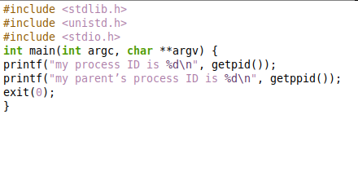

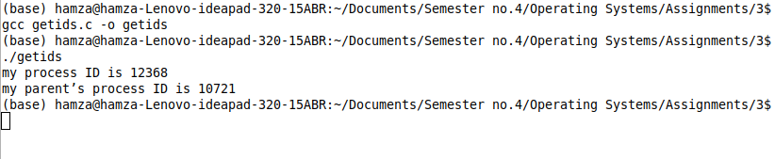

**Task 02:**

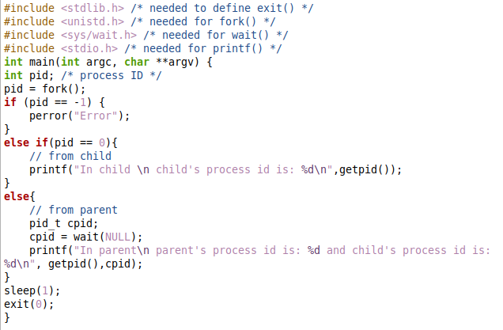

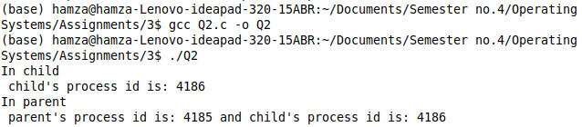

**Task 03:**



